Internet Safety for Students
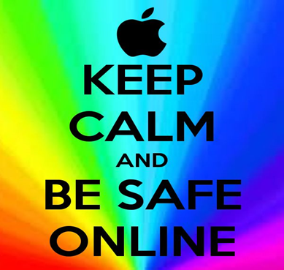

- NEVER give out personal information
- Name, home address, phone number and your school name should not be mentioned to people you do not know.
- Never send a picture of yourself without parental permission.
- Never give people your passwords. This includes friends!
- When choosing a screen name, do not include personal info such as your last name of birth date.

- NEVER meet someone or have them visit you without permission
- Tell your parents immediately if someone asks to meet you or wants to come to your house.

- Be careful what you post on the internet
- Be careful of the information and pictures you post on the internet. This includes Facebook, Twitter, Instagram and Musically.
- Beware of online predators. People online might not be who they say they are.

- Beware of Cyber Bullying
- Do not say anything online that you would not want your parents to see or hear.
- Do not respond to online bullying and save all posts and messages received.
- Report cyber bullying to your parents immediately. Report it to your principal, teacher or counselor if it is happening with someone at school.

- Online Gaming
- Do not “friend” people on Xbox Live or Play Station Network that you do not know in person.
- Do not give person information over headsets to people you do not know.
- Tell a parent about anything that makes you uncomfortable.
- Be careful of downloading or buying things that your parents have not approved.

REMEMBER….IF IT MAKES YOU FEEL UNCOMFORTABLE….IT’S PROBABLY WRONG! TELL SOMEONE IMMEDIATELY! BE SAFE!

